[Project Tracker]
Business Requirements Document (BRD)

Version i.1

Revision History

S.N | Date | Description | Version | Author | Reviewer | Remarks
1 | 8/18/2014 | Initial draft of BRD | 0.1

UTORS

Table of Contents

Revision History ii

Project Details 2

Overview 2

Document Resources 2

Project Overview 3
4.1 Project Overview and Background 3
4.2 Project Dependencies 3
4.3 Stakeholders 3

Key Assumptions and Constraints 3
5.1 Key Assumptions and Dependencies 3

Use Cases 4
Use Case Diagram 4
Use Case Narrative 5

Business Requirements 8

Business Requirements 8

Process Flow Diagram 10
Current Process Flow Diagram 10
Reengineered Process Flow Diagram 10

Appendix: 12
Acronym 12

Project Details

Project Name | Project Tracker
Project Type | Implementation
Project Start Date
Project End Date
Project Sponsor
Project Manager/Dept

Overview

This document defines the high level requirements of “Project Tracker”. It will be used as the basis for the following activities:

- Keep records of project done by each student
- View the records of student profile
- View the current status of project done by each student
- Track the project records of each student by name or project.

Document Resources

Name | Business Unit | Role
Students |  | User
College Administration |  | Admin
Teachers |  | Faculty

Project Overview

4.1 Project Overview and Background
The number of students are growing every year. Many of them have to get involved in some projects to complete their studies. They have to search a lot to decide which project to perform and which have been already performed. Searching might be very time consuming. For faculties too, it is very hard to track every project done by his/her students and know how far they have completed.
<This information can be taken from the Project Charter. This is a brief description of what the project is about. It includes the current situation, the problem and the objectives. This section serves as the vision statement for the requirements. Each requirement should bring the project closer to the vision.>

4.2 Project Dependencies
<List any related known projects that relate in whole or in part, or has a dependency on this project.>

4.3 Stakeholders
The following comprises the internal and external stakeholders whose requirements are represented by this document:

 | Stakeholders | Roles and Responsibilities

Key Assumptions and Constraints

5.1 Key Assumptions and Dependencies

# | Assumptions
 | List any assumptions the requirements are based on
# | Dependencies
 | List any constraints the requirements are based on

Use Cases
< The primary purpose of the Use Case is to capture the required system behavior from the perspective of the end-user in achieving one or more desired goals. A Use Case contains a description of the flow of events describing the interaction between actors and the system. The use case may also be represented visually in UML in order to show relationships with other the use cases and actors>.

Use Case Diagram

Use Case Narrative

<Each Use Case should be documented using this template. Refer to the Appendix for Use Case Narrative instructions>

Use Case ID:
Use Case Name:
Created By: |  | Last Updated By:
Date Created: |  | Date Last Updated:

Actors:
Description:
Preconditions:
Postconditions:
Normal Course:
Alternative Courses:
Exceptions:
Includes:
Priority:
Frequency of Use:
Business Rules
Special Requirements:
Assumptions:
Notes and Issues:
Use Case Graphic

Example of a completed use case:

Use Case ID: | 1
Use Case Name: | View Interactive Campus Map
Created By: | Dan Sward | Last Updated By:
Date Created: | 4/19/09 | Date Last Updated:

Actors: | User
Description: | This use case describes the main way this interactive campus map will be used – as a web browser accessed application. The user accesses the appropriate URL and interacts with the functionality made available.
Preconditions: | Web browser opened, and interactive campus map URL accessed.
Postconditions: | User navigates from interactive campus map web site.
Normal Course: | - Open browser  - Navigate to campus map URL  - Interact with the campus map using available functionality
Alternative Courses: | None
Exceptions: | None
Includes:
Priority: | High
Frequency of Use: | Once per visit.
Business Rules | TBD…
Special Requirements: | - 24/7 access  - Response times comparable to common web mapping solutions (e.g. Google Maps)  - U of M accessibility requirements  - U of M eCommunications requirements
Assumptions:
Notes and Issues:
Use Case Graphic | 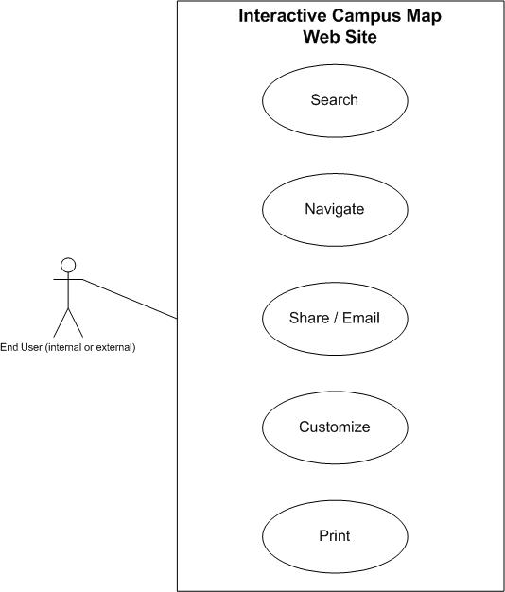

Business Requirements

The following sections document the various business requirements of this project.

Requirement Type | ID – Prefix ?? | ID – Number | Function – Feature - Requirement | Use Case Reference | Comments
 | f | 0001
 | f | 0002
 | f | 0003
 | f | 0004
 | F | 0005
 | F | 0007
 | f | 0007
 | f | 0008
 | f | 0001
 | f | 0002
 | f | 0003
 | f | 0004
 | F | 0005
 | F | 0007
 | f | 0007
 | f | 0008
 | f | 0001
 | f | 0002
 | f | 0003
 | f | 0004
 | F | 0005
 | F | 0007
 | f | 0007
 | f | 0008
 | f | 0001
 | f | 0002
 | f | 0003
 | f | 0004
 | F | 0005
 | F | 0007
 | f | 0007
 | f | 0008
 | f | 0001
 | f | 0002
 | f | 0003
 | f | 0004
 | F | 0005
 | F | 0007
 | f | 0007
 | f | 0008
 | f | 0001
 | f | 0002
 | f | 0003
 | f | 0004
 | F | 0005
 | F | 0007
 | f | 0007
 | f | 0008

Process Flow Diagram

Current Process Flow Diagram

Reengineered Process Flow Diagram

Example of process flow diagram:

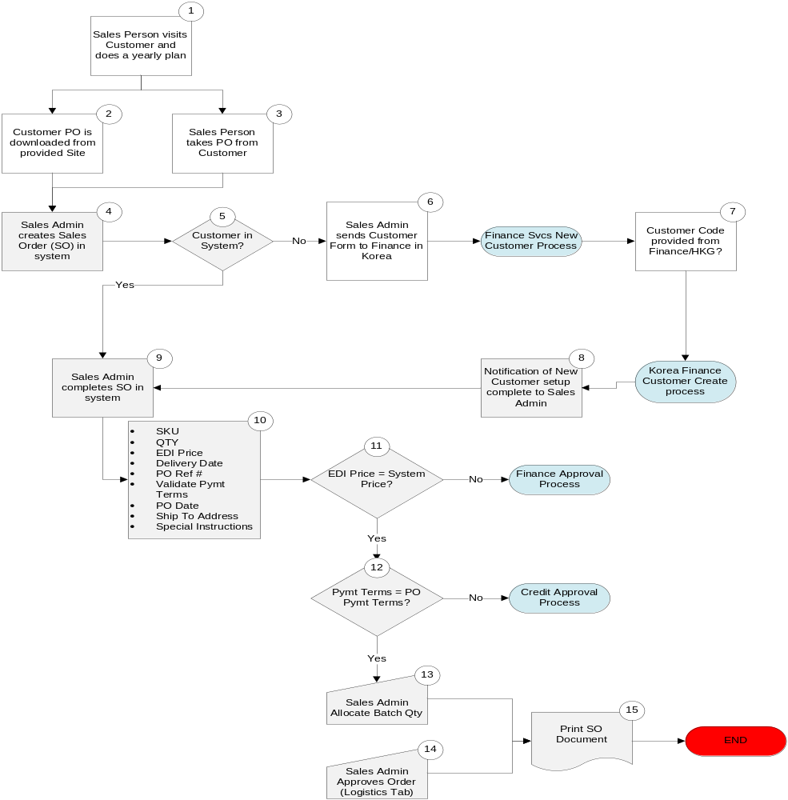

Appendix:

Acronym

Term/Acronym | Definition
<Identify any terms and acronyms used within this document>

